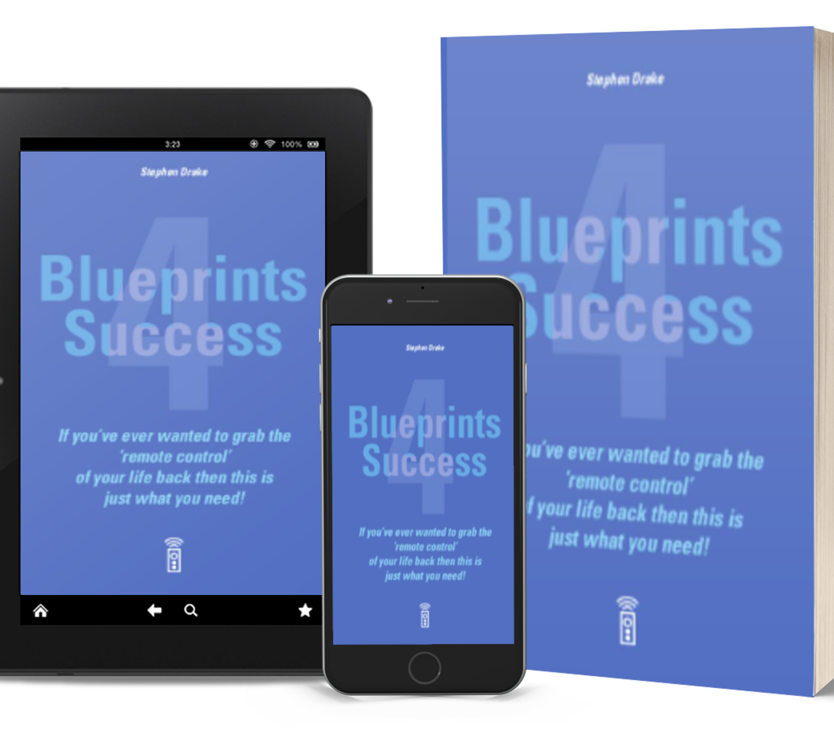BLUEPRINTS
4
SUCCESS WORKBOOK

Stephen Drake

“Change happens when the pain of staying the same is greater than the pain of change.”

Tony Robbins

Unlocking Success:

Starting a new project or task can be daunting, but the key to success is just getting started. And how do you get started? By breaking down complex, overwhelming tasks into smaller, more manageable ones and tackling one at a time.
Remember, the secret to getting ahead is simply getting started.

Daily Journal
DATE:
write a description here

TODAY I’M FEELING…
I'M GRATEFUL FOR…
MY AFFIRMATIONS OF THE DAY
I WANT TO FOCUS ON
MY GOALS FOR TODAY ARE…

Manifest it
Once you've set your intention write it down. Remember to make it as specific as possible.

My Daily Planner
write a description here.

I WANT TO MANIFEST

MY DAILY AFFIRMATIONS

LIMITING BELIEFS, I WANT TO LET GO

ACTION STEPS
TO-DO LIST

Top Yearly Goals
my top goals for the next 12 months

PERSONAL GROWTH

CAREER / JOB / FINANCES

LEARNING / STUDY

ENVIRONMENT / HOME

FAMILY, FRIENDS & LOVE

Goal In Depth

ONE TIME GOAL HABIT GOAL

PERSONAL GROWTH
CAREER/JOB/FINANCES
LEARNING/STUDY
ENVIRONMENT/HOME
FAMILY/FRIENDS/LOVE
my goal Write a detailed goal description

benefits Why do you want to achieve this goal?

actionable steps What can you do to achieve this goal?

rewards How will you reward yourself once you achieve this goal?

Monthly PROGRESS TRACKER Assess your progress.

MONTH | J | F | M | A | M | J | J | A | S | O | N | D
SCORE (1-5)

Goal In Depth

ONE TIME GOAL HABIT GOAL

PERSONAL GROWTH
CAREER/JOB/FINANCES
LEARNING/STUDY
ENVIRONMENT/HOME
FAMILY/FRIENDS/LOVE
my goal Write a detailed goal description

benefits Why do you want to achieve this goal?

actionable steps What can you do to achieve this goal?

rewards How will you reward yourself once you achieve this goal?

Monthly PROGRESS TRACKER Assess your progress.

MONTH | J | F | M | A | M | J | J | A | S | O | N | D
SCORE (1-5)

Goal In Depth

ONE TIME GOAL HABIT GOAL

PERSONAL GROWTH
CAREER/JOB/FINANCES
LEARNING/STUDY
ENVIRONMENT/HOME
FAMILY/FRIENDS/LOVE
my goal Write a detailed goal description

benefits Why do you want to achieve this goal?

actionable steps What can you do to achieve this goal?

rewards How will you reward yourself once you achieve this goal?

Monthly PROGRESS TRACKER Assess your progress.

MONTH | J | F | M | A | M | J | J | A | S | O | N | D
SCORE (1-5)

Goal In Depth

ONE TIME GOAL HABIT GOAL

PERSONAL GROWTH
CAREER/JOB/FINANCES
LEARNING/STUDY
ENVIRONMENT/HOME
FAMILY/FRIENDS/LOVE
my goal Write a detailed goal description

benefits Why do you want to achieve this goal?

actionable steps What can you do to achieve this goal?

rewards How will you reward yourself once you achieve this goal?

Monthly PROGRESS TRACKER Assess your progress.

MONTH | J | F | M | A | M | J | J | A | S | O | N | D
SCORE (1-5)

Goal In Depth

ONE TIME GOAL HABIT GOAL

PERSONAL GROWTH
CAREER/JOB/FINANCES
LEARNING/STUDY
ENVIRONMENT/HOME
FAMILY/FRIENDS/LOVE
my goal Write a detailed goal description.

benefits Why do you want to achieve this goal?

actionable steps What can you do to achieve this goal?

rewards How will you reward yourself once you achieve this goal?

Monthly PROGRESS TRACKER Assess your progress.

MONTH | J | F | M | A | M | J | J | A | S | O | N | D
SCORE (1-5)

Goal Review & Reflection

TOP ACCOMPLISHMENTS WHAT ARE YOU PROUD OF?

GOAL PERFORMANCE WHAT WORKED? WHAT DIDN'T?

CONCLUSIONS

I will keep ...

I will improve ...

I will start ...

I will stop ...

Life Goals

(not categorized)

GOAL DESCRIPTION | DATE

Goal Planner

Goal Name:
Start Date: End Date:
Priority: Difficulty:

TO DO

 | TASK DESCRIPTION |  | TIME |  | RESOURCES
1
2
3
4
5
6
7
8
9
10
11
12

Notes

Session Notes

DATE:

FOR DEEP MEDITATION AND OTHER SPIRITUAL EVENTS

TODAY' S TOPICS SESSION NOTES

IMPORTANT CONCLUSIONS

HOW I FEEL NOW ... FOR NEXT SESSION

Session Notes
THIS SESSION' S FOCUS

DATE:

TOPICS I WANT TO WORK WITH

ACTION PLAN
SESSION NOTES

I FEEL ... FOR NEXT SESSION

Weekly Gratitude Journal
Sunday
Saturday
Friday
Thursday
Wednesday
Tuesday
a simple description

I'M GRATEFUL FOR BECAUSE
Monday

Weekly Spiritual Plan

a simple description

MO TU WE TH FR SA SU
Meditation
Affirmations
Course
Acroyoga
Dharma
Other
Other

My intentions

Notes

30 Day Challenge
a simple description

01 |  | 02 |  | 03 |  | 04 |  | 05
06 |  | 07 |  | 08 |  | 09 |  | 10
11 |  | 12 |  | 13 |  | 14 |  | 15
16 |  | 17 |  | 18 |  | 19 |  | 20
21 |  | 22 |  | 23 |  | 24 |  | 25
26 |  | 27 |  | 28 |  | 29 |  | 30

Priority Matrix
Not essential
Important
list your hopes, dreams and goals

URGENT NOT URGENT
WANT FIRST
WANT NEXT
DON'T WANT YET
DON'T WANT EVER

To-Do List

write description here

WHAT
WHEN
PRIORITY

My Activity Tracker
write description here

TASK
TASK lenght

NOTES:

My Distraction List
what hinders me regularly to achieve my goals?

WHAT
WHEN
WHY
ERASE

My Activity Tracker
Assess your performance for each task
1 = very bad 2 = bad 3 = okay 4 = good
5 = excellent

 |  |  |  | day |  |  |  |  |  |  |  |  | day
WEEK 1 | 1 | 2 | 3 | 4 | 5 | 6 | 7 |  | WEEK 2 | 1 | 2 | 3 | 4 5 6 7
MANIFESTING  MEDITATING  VISUALIZING  READING  ............................. |  |  |  |  |  |  |  |  | MANIFESTING  MEDITATING  VISUALIZING  READING  .............................
TOTAL DAILY |  |  |  |  |  |  |  |  | TOTAL DAILY

 |  |  |  | day |  |  |  |  |  |  |  |  | day
WEEK 3 | 1 | 2 | 3 | 4 | 5 | 6 | 7 |  | WEEK 4 | 1 | 2 | 3 | 4 5 6 7
MANIFESTING  MEDITATING  VISUALIZING  READING |  |  |  |  |  |  |  |  | MANIFESTING  MEDITATING  VISUALIZING  READING
............................. |  |  |  |  |  |  |  |  | .............................
TOTAL DAILY |  |  |  |  |  |  |  |  | TOTAL DAILY
My Total Monthly Score:

Visualization journal
write description here

VISUALIZATION

I see

I have

I feel

notes:

Discard what is useless
Start with writing down everything that is cluttering your mind focusing on false beliefs that hold you back and negative influences that you want to get rid of.

WHAT FALSE TRUTHS DO I CONTINUE TO TELL MYSELF?
WHAT LIMING BELIEFS ARE STILL HOLDING ME BACK?
WHAT HAS BEEN A BURDEN FOR TOO LONG?
WHAT DO I WANT TO GET RID OF ONCE AND FOR ALL?

Gratitude Journal Day 1

TODAY I AM GRATEFUL FOR...

I WILL HAVE A POSITIVE ATTITUDE FROM NOW ON WHENEVER I EXPERIENCE...

I TOOK THESE THINGS FOR GRANTED...

I NOTICED THIS BECAUSE I WAS FULLY PRESENT...

I FELT JOY TODAY WHEN...

WHAT IS YOUR RELATIONSHIP WITH GRATITUDE AT THIS POINT IN YOUR LIFE?

Gratitude Journal Day 2

TODAY I AM GRATEFUL FOR...

I WILL HAVE A POSITIVE ATTITUDE FROM NOW ON WHENEVER I EXPERIENCE...

I TOOK THESE THINGS FOR GRANTED...

I NOTICED THIS BECAUSE I WAS FULLY PRESENT...

I FELT JOY TODAY WHEN...

WHAT IS YOUR RELATIONSHIP WITH GRATITUDE AT THIS POINT IN YOUR LIFE?

Gratitude Journal Day 3

TODAY I AM GRATEFUL FOR...

I WILL HAVE A POSITIVE ATTITUDE FROM NOW ON WHENEVER I EXPERIENCE...

I TOOK THESE THINGS FOR GRANTED...

I NOTICED THIS BECAUSE I WAS FULLY PRESENT...

I FELT JOY TODAY WHEN...

WHAT IS YOUR RELATIONSHIP WITH GRATITUDE AT THIS POINT IN YOUR LIFE?

Gratitude Journal Day 4

TODAY I AM GRATEFUL FOR...

I WILL HAVE A POSITIVE ATTITUDE FROM NOW ON WHENEVER I EXPERIENCE...

I TOOK THESE THINGS FOR GRANTED...

I NOTICED THIS BECAUSE I WAS FULLY PRESENT...

I FELT JOY TODAY WHEN...

WHAT IS YOUR RELATIONSHIP WITH GRATITUDE AT THIS POINT IN YOUR LIFE?

Gratitude Journal Day 5

TODAY I AM GRATEFUL FOR...

I WILL HAVE A POSITIVE ATTITUDE FROM NOW ON WHENEVER I EXPERIENCE...

I TOOK THESE THINGS FOR GRANTED...

I NOTICED THIS BECAUSE I WAS FULLY PRESENT...

I FELT JOY TODAY WHEN...

WHAT IS YOUR RELATIONSHIP WITH GRATITUDE AT THIS POINT IN YOUR LIFE?

Gratitude Journal Day 6

TODAY I AM GRATEFUL FOR...

I WILL HAVE A POSITIVE ATTITUDE FROM NOW ON WHENEVER I EXPERIENCE...

I TOOK THESE THINGS FOR GRANTED...

I NOTICED THIS BECAUSE I WAS FULLY PRESENT...

I FELT JOY TODAY WHEN...

WHAT IS YOUR RELATIONSHIP WITH GRATITUDE AT THIS POINT IN YOUR LIFE?

Gratitude Journal Day 7

TODAY I AM GRATEFUL FOR...

I WILL HAVE A POSITIVE ATTITUDE FROM NOW ON WHENEVER I EXPERIENCE...

I TOOK THESE THINGS FOR GRANTED...

I NOTICED THIS BECAUSE I WAS FULLY PRESENT...

I FELT JOY TODAY WHEN...

WHAT IS YOUR RELATIONSHIP WITH GRATITUDE AT THIS POINT IN YOUR LIFE?

My Prayer to the Universe

Write your prayer to the universe in the space down below. Don't forget to be clear, concise and specific. The universe gives you what you are, not what you want.

My affirmations

MY AFFIRMATIONS

1.

2.

3.

4.

5.

6.

7.

8.

9.

10.

Self-love & self-acceptance Affirmations

1. I am worthy of love and respect.
2. I love and accept myself unconditionally.
3. I choose to focus on my strengths and positive qualities.
4. I let go of self-criticism and embrace self-love.
5. I forgive myself for past mistakes and move forward with self-compassion.
6. I am grateful for my unique qualities and talents.
7. I am comfortable in my own skin and proud of who I am.
8. I honor and respect my body and mind.
9. I am deserving of all the good things life has to offer.
10. I trust my intuition and inner wisdom.
11. I let go of comparing myself to others and embrace my own journey.
12. I am authentic and true to myself.
13. I am confident in expressing my needs and boundaries.
14. I take care of myself physically, mentally, and emotionally.
15. I am deserving of love and happiness.
16. I am worthy of my own love and affection.
17. I appreciate and love myself more each day.
18. I am proud of who I am and what I stand for.
19. I choose to be kind and compassionate towards myself.
20. I let go of negative self-talk and embrace positive affirmations.
21. I trust that I am capable of achieving my goals and dreams.
22. I am comfortable with who I am and where I am in life.
23. I am confident in my abilities and choices.
24. I let go of seeking external validation and trust in my own worth.
25. I am grateful for my own unique journey and experiences.
26. I acknowledge and celebrate my own accomplishments and successes.
27. I am empowered to create my own happiness and fulfillment.
28. I love and accept myself just as I am.
29. I trust that I am enough just as I am.
30. I am constantly growing and learning to love myself more each day.

Confidence & self-esteem Affirmations

1. I am confident in my abilities and decisions.
2. I trust in my own judgement and intuition.
3. I am worthy of success and happiness.
4. I am proud of my accomplishments and achievements.
5. I believe in myself and my potential.
6. I am deserving of respect and recognition.
7. I am confident in expressing my opinions and ideas.
8. I am fearless in pursuing my goals and dreams.
9. I am comfortable with taking risks and stepping outside of my comfort zone.
10. I am resilient in the face of challenges and setbacks.
11. I am capable of overcoming any obstacles that come my way.
12. I am confident in my own skin and proud of who I am.
13. I am deserving of love and positive relationships.
14. I attract success and positive opportunities into my life.
15. I am confident in my own worth and value.
16. I am worthy of being treated with kindness and respect.
17. I am confident in my ability to learn and grow.
18. I am capable of achieving anything I set my mind to.
19. I trust that I am on the right path towards my goals.
20. I am grateful for my unique talents and abilities.
21. I am confident in my own creativity and innovation.
22. I am comfortable in asserting my boundaries and saying no when necessary.
23. I am confident in my ability to handle any situation that arises.
24. I am proud of who I am and what I stand for.
25. I am deserving of success and abundance.
26. I trust in my own strength and resilience.
27. I am capable of overcoming any fear or self-doubt.
28. I am confident in my own worth and value.
29. I am proud of my own accomplishments and successes.
30. I am empowered to create the life I desire with confidence and self-esteem.

Career & success Affirmations

1. I am worthy of success and abundance in my career.
2. I attract positive opportunities and success into my life.
3. I am confident in my abilities to excel in my career.
4. I am committed to achieving my career goals and dreams.
5. I am constantly learning and growing in my career.
6. I trust in my own skills and expertise to succeed.
7. I am capable of overcoming any challenges in my career.
8. I am open to new possibilities and opportunities for success.
9. I am deserving of recognition and respect in my career.
10. I am grateful for the work that I do and the impact it has.
11. I am confident in my ability to make a difference in my career.
12. I am aligned with my career path and purpose.
13. I am constantly attracting new and exciting opportunities in my career.
14. I am committed to lifelong learning and growth in my career.
15. I am proud of my accomplishments and successes in my career.
16. I am capable of achieving any career goals I set for myself.
17. I am confident in expressing my ideas and opinions in my career.
18. I am deserving of financial abundance and prosperity in my career.
19. I am committed to balancing my career success with my personal life.
20. I am comfortable taking calculated risks in my career.
21. I am confident in my ability to network and build positive relationships in my career.
22. I am grateful for the supportive people in my career.
23. I am constantly improving my skills and knowledge in my career.
24. I am deserving of promotions and advancement in my career.
25. I am confident in my ability to adapt to new changes and challenges in my career.
26. I am focused and driven towards achieving my career goals.
27. I am capable of achieving a fulfilling and satisfying career.
28. I am proud of the work that I do and the impact it has on others.
29. I am confident in my own value and worth in my career.
30. I am empowered to create the career and success I desire.

Relationships & connection Affirmations

1. I am deserving of love and positive relationships.
2. I attract healthy and loving relationships into my life.
3. I am surrounded by supportive and uplifting people.
4. I am open to connecting with new and positive people.
5. I am worthy of deep and meaningful connections with others.
6. I trust in the power of vulnerability in building strong relationships.
7. I am committed to fostering healthy and positive relationships.
8. I am capable of communicating my needs and boundaries in relationships.
9. I am open to giving and receiving love in my relationships.
10. I am grateful for the positive relationships in my life.
11. I am confident in expressing my love and affection for others.
12. I am committed to cultivating mutual respect and trust in my relationships.
13. I am capable of forgiving and letting go of past hurt in relationships.
14. I am worthy of being treated with kindness and respect in relationships.
15. I am open to learning and growing from my relationships.
16. I am capable of healthy and effective communication in my relationships.
17. I trust in my ability to attract and maintain healthy relationships.
18. I am deserving of genuine and authentic connections with others.
19. I am committed to working through challenges in my relationships.
20. I am comfortable setting and enforcing healthy boundaries in relationships.
21. I am confident in expressing my emotions and feelings in relationships.
22. I am open to learning and growing from different perspectives in relationships.
23. I am grateful for the lessons and growth that come from relationships.
24. I am capable of creating and maintaining fulfilling relationships.
25. I am committed to showing up authentically in my relationships.
26. I am confident in expressing my appreciation and gratitude for others.
27. I am open to receiving love and support from others.
28. I am capable of fostering strong and lasting connections with others.
29. I am deserving of fulfilling and satisfying relationships.
30. I am empowered to create the positive relationships and connections I desire.

Creativity & self-expression Affirmations

1. I am a creative and imaginative person.
2. I trust in my ability to express myself authentically and creatively.
3. I am worthy of pursuing my creative passions and interests.
4. I am open to new and innovative ideas for my creative projects.
5. I am capable of overcoming creative blocks and obstacles.
6. I am committed to exploring my creativity and expressing myself.
7. I trust in my own unique creative process.
8. I am capable of tapping into my creative flow at any time.
9. I am grateful for the inspiration and ideas that come to me.
10. I am confident in sharing my creative work with others.
11. I am deserving of recognition and appreciation for my creative endeavors.
12. I am committed to exploring and experimenting with different creative mediums.
13. I am open to learning and growing as a creative individual.
14. I trust in my intuition and creativity to guide me in my projects.
15. I am capable of turning my creative visions into reality.
16. I am worthy of devoting time and energy to my creative pursuits.
17. I am confident in my ability to handle constructive criticism and feedback.
18. I am open to collaborating with other creatives and artists.
19. I trust in my own voice and perspective in my creative work.
20. I am grateful for the opportunities to express my creativity and imagination.
21. I am capable of balancing my creative passions with other responsibilities.
22. I am committed to making time for my creative projects and endeavors.
23. I am confident in sharing my unique perspective and ideas with others.
24. I am open to exploring different forms of self-expression.
25. I trust in my own creativity to bring joy and fulfillment into my life.
26. I am deserving of success and recognition for my creative work.
27. I am capable of pushing past creative boundaries and limitations.
28. I am committed to honing and improving my creative skills.
29. I am grateful for the inspiration and ideas that come to me.
30. I am empowered to embrace and express my unique creativity and self-expression.

Gratitude & abundance Affirmations

1. I am grateful for all the blessings in my life.
2. I trust in the universe to provide me with abundance and prosperity.
3. I am worthy of experiencing abundance and prosperity in all areas of my life.
4. I am open to receiving abundance and prosperity in all forms.
5. I am capable of recognizing and appreciating the abundance in my life.
6. I am committed to cultivating a mindset of abundance and gratitude.
7. I trust in the flow of abundance and prosperity in my life.
8. I am capable of attracting and manifesting abundance and prosperity.
9. I am grateful for the opportunities that come my way.
10. I am confident in my ability to create abundance and prosperity for myself.
11. I am deserving of success and abundance in my career and finances.
12. I am open to the abundance of love and joy in my relationships.
13. I trust in the power of gratitude to attract abundance and prosperity.
14. I am capable of letting go of scarcity and lack mentality.
15. I am grateful for the lessons and growth that come from challenges.
16. I am committed to expressing gratitude for the small things in life.
17. I trust in the universe to provide me with what I need at the right time.
18. I am deserving of a life filled with abundance and prosperity.
19. I am open to the opportunities and possibilities that come my way.
20. I am capable of creating a life of abundance and prosperity for myself and others.
21. I am grateful for the support and love of those around me.
22. I am confident in my ability to overcome obstacles and challenges.
23. I am open to the abundance of health and well-being in my life.
24. I trust in my own intuition and inner guidance for abundance and prosperity.
25. I am capable of taking action towards my goals and dreams.
26. I am deserving of abundance and prosperity in all areas of my life.
27. I am committed to expressing gratitude for the present moment.
28. I trust in the infinite possibilities and potential of the universe.
29. I am grateful for the abundance and prosperity that is already in my life.
30. I am empowered to create and manifest the abundance and prosperity I desire.

Inner peace & mindfulness Affirmations

1. I am at peace with myself and the world around me.
2. I trust in the power of mindfulness to bring calm and serenity into my life.
3. I am worthy of experiencing inner peace and tranquility.
4. I am open to practicing mindfulness in all areas of my life.
5. I am capable of letting go of negative thoughts and emotions.
6. I am committed to cultivating a mindset of peace and mindfulness.
7. I trust in the power of the present moment to bring clarity and focus.
8. I am capable of finding stillness and calmness in any situation.
9. I am grateful for the moments of peace and tranquility in my life.
10. I am confident in my ability to handle stress and challenges with ease and grace.
11. I am deserving of a life filled with inner peace and harmony.
12. I am open to the healing power of meditation and mindfulness practices.
13. I trust in my own inner wisdom to guide me towards peace and mindfulness.
14. I am capable of taking time for self-care and self-reflection.
15. I am grateful for the lessons and growth that come from difficult experiences.
16. I am committed to living a mindful and intentional life.
17. I trust in my ability to find peace and calmness within myself.
18. I am deserving of love, kindness, and compassion towards myself and others.
19. I am open to learning and growing through mindfulness practices.
20. I am capable of finding joy and happiness in the present moment.
21. I am grateful for the beauty and wonder of the world around me.
22. I am confident in my ability to stay centered and grounded in the midst of chaos.
23. I am open to the wisdom and guidance of others who practice mindfulness.
24. I trust in the power of gratitude to bring peace and contentment into my life.
25. I am capable of finding balance and harmony in all aspects of my life.
26. I am deserving of rest and relaxation to nourish my mind, body, and soul.
27. I am committed to embracing the impermanence of life with grace and acceptance.
28. I trust in my own ability to cultivate inner peace and mindfulness every day.
29. I am grateful for the opportunities to practice mindfulness and find inner peace.
30. I am empowered to find stillness, peace, and contentment within myself.

Courage and resilience Affirmations

1. I am strong and capable of overcoming any challenge.
2. I have the power to choose my thoughts and emotions.
3. I face adversity with courage and determination.
4. I embrace change and grow from it.
5. I am resilient and bounce back from setbacks.
6. I trust in my ability to handle difficult situations.
7. I am courageous and willing to take risks.
8. I face my fears with bravery and confidence.
9. I am unstoppable and persistent in achieving my goals.
10. I trust in the journey and believe in myself.
11. I am resilient and adaptable to change.
12. I am confident in my ability to handle anything that comes my way.
13. I choose to focus on the positive and find the silver lining.
14. I am brave and stand up for what I believe in.
15. I am strong and capable of overcoming any obstacle.
16. I trust in my inner strength and wisdom.
17. I am resilient and capable of bouncing back from any setback.
18. I am courageous in the face of uncertainty and doubt.
19. I am unbreakable and capable of overcoming any challenge.
20. I trust in my ability to persevere through difficult times.
21. I am brave and face my fears head-on.
22. I am resilient and capable of handling anything life throws my way.
23. I choose to let go of fear and embrace courage.
24. I am confident in my ability to handle stress and pressure.
25. I am brave and take action despite my fears.
26. I am strong and capable of achieving my dreams.
27. I trust in my ability to overcome any obstacle with grace and ease.
28. I am resilient and adaptable to changing circumstances.
29. I am courageous and empowered to create the life I want.
30. I choose to believe in myself and my potential for greatness.

Financial Affirmations

- I am worthy of financial abundance and prosperity.
- Money flows to me easily and effortlessly.
- I am grateful for the abundance in my life, both financial and otherwise.
- I attract wealth and success with every action I take.
- I release all limiting beliefs about money and abundance.
- I am open to receiving abundance in all areas of my life.
- I trust in my ability to make smart financial decisions.
- I am aligned with the energy of abundance and prosperity.
- My financial abundance grows every day.
- I deserve to be financially successful and secure.
- I am surrounded by positive financial opportunities.
- I am financially responsible and make wise choices with my money.
- I have more than enough money to meet my needs and desires.
- I am worthy of living a life of financial freedom.
- My income is constantly increasing.
- I am grateful for the financial abundance that I have and continue to receive.
- I am always in the right place at the right time to receive financial opportunities.
- My financial goals are achievable and within reach.
- My wealth and abundance positively impact the lives of those around me.
- I trust that the universe will always provide for me.
- I am grateful for the wealth and prosperity that comes into my life.
- I am financially abundant in all aspects of my life.
- I am confident in my ability to create financial abundance and success.
- I am a magnet for financial success and prosperity.
- I attract financial abundance effortlessly.
- Money is a tool that allows me to live the life I desire.
- I am worthy of having financial security and stability.
- I am able to manifest the financial abundance I desire.
- I am grateful for the financial freedom and flexibility in my life.
- I am always open to receiving unexpected financial blessings and opportunities.

My Top Three

write a description here

3.
2.
1.
MY TOP 3 GOALS
3.
2.
1.
MY TOP 3 HABITS

3.
2.
1.
MY TOP 3 ACTION STEPS
3.
2.
1.
MY TOP 3 BENEFITS

3.
2.
1.
MY TOP 3 SUPPORTERS
3.
2.
1.
MY TOP 3 LETTING GO

Gratitude Letter 1

Pick someone that you love dearly. Write everything that makes you grateful about them and what you would like to tell them. Send love and kindness to that person through your words.

Gratitude Letter 2

Pick someone that you love dearly. Write everything that makes you grateful about them and what you would like to tell them. Send love and kindness to that person through your words.

Gratitude Letter 3

Pick someone that you love dearly. Write everything that makes you grateful about them and what you would like to tell them. Send love and kindness to that person through your words.

Minor Tasks List
It's common to have a bunch of small tasks floating around in our heads, like scheduling a check-up or getting those new jeans tailored. Even though these tasks may not seem urgent, they can quickly accumulate and cause us stress.
It's easy to keep putting them off, but did you know that they actually take up a lot of mental energy? So, why not write them down and free up some headspace?

Let's make a list of all those little tasks that are bugging you:

Worry Page

WHAT ARE YOU WORRIED ABOUT RIGHT NOW?
Use the categories below to help you identify any hidden worries.

FAMILY | MONEY | FRIENDS | SELF-GROWTH | CAREER | LOVE LIFE | HEALTH | HOUSEHOLD

RANDOM RANT GOES HERE

Fear Page

ANY PARTICULAR FEARS? OLD OR NEW ONES?
it's okay to be afraid. Fear is there to protect us. Sometimes fear is useful, sometimes it prevents us from living our best life.

FAMILY | MONEY | FRIENDS | SELF-GROWTH | CAREER | LOVE LIFE | HEALTH | HOUSEHOLD

Action Page
CAN YOU DO ANYTHING ABOUT THE TOPICS THAT ARE CAUSING WORRIES AND FEARS?

DO ANY OF THEM NEED URGENT ACTION?

Sometimes we worry about things that are not really our responsibility and out of our control. WOULD YOU LIKE TO EMOTIONALLY DELEGATE SOME OF THESE ISSUES TO THE PEOPLE RESPONSIBLE FOR THEM?

ARE YOU PROCRASTINATING ANYTHING THAT YOU WOULD LIKE TO SCHEDULE NOW?

Sometimes we have to make decisions that we don't feel confident of making at that moment in our live. Then they pile up and make us feel weak and powerless if we don't do anything about them.
ARE THERE ANY DECISIONS YOU FEEL READY TO MAKE NOW?

Brain Dump

INHALE DEEPLY, EXHALE VERY SLOWLY.

So many thoughts taking up space in your head can be overwhelming and cause a foggy and unrestful mind.
It's a good thing to get it all out of your head. Let all those thoughts flow out of your hand. Write until you feel like the pressure inside of you is gone.

Congrats! You have written everything down. You can now give yourself permission to breathe and relax.

CONCLUDING THOUGHTS

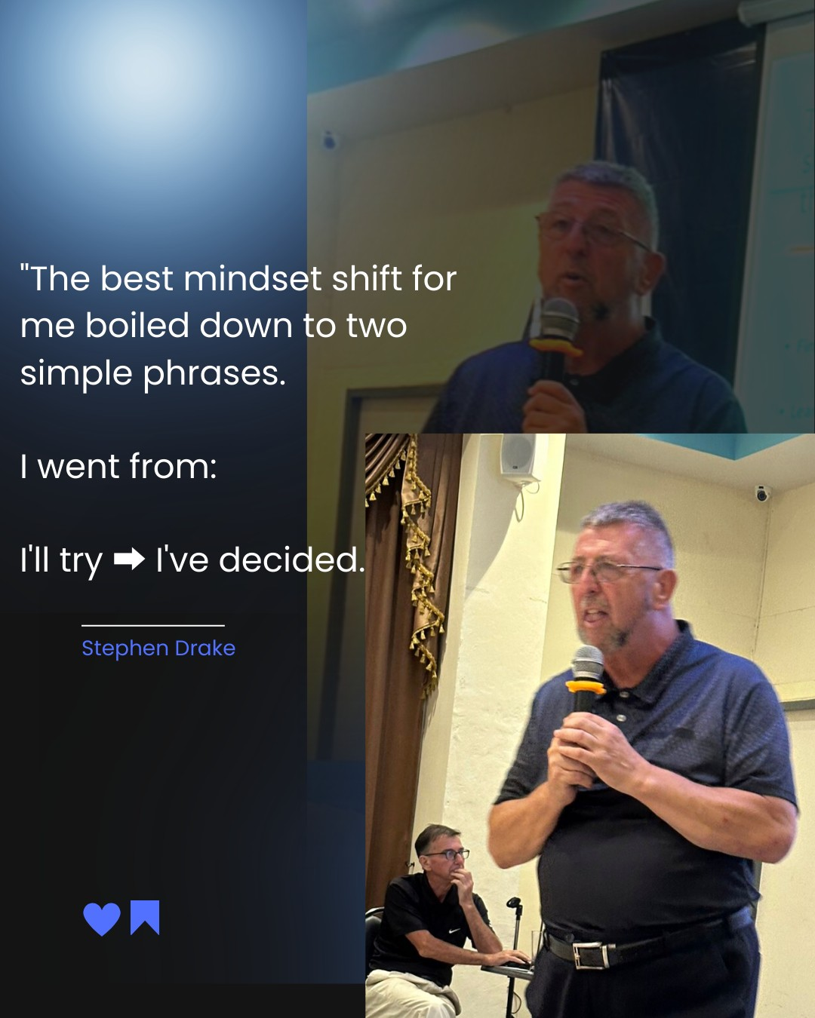

Stephen Drake - Author - Coach - Consultant - Mentor - Trainer

Until the next time

BP4S 2023

